NAME:

D.nithish

LAB ASSIGNMENT 4.2

HTNO:2303A51048

Task 1: Zero-Shot Prompting
Prompt Used: Write a Python function to determine whether a given number is prime.

CODE:
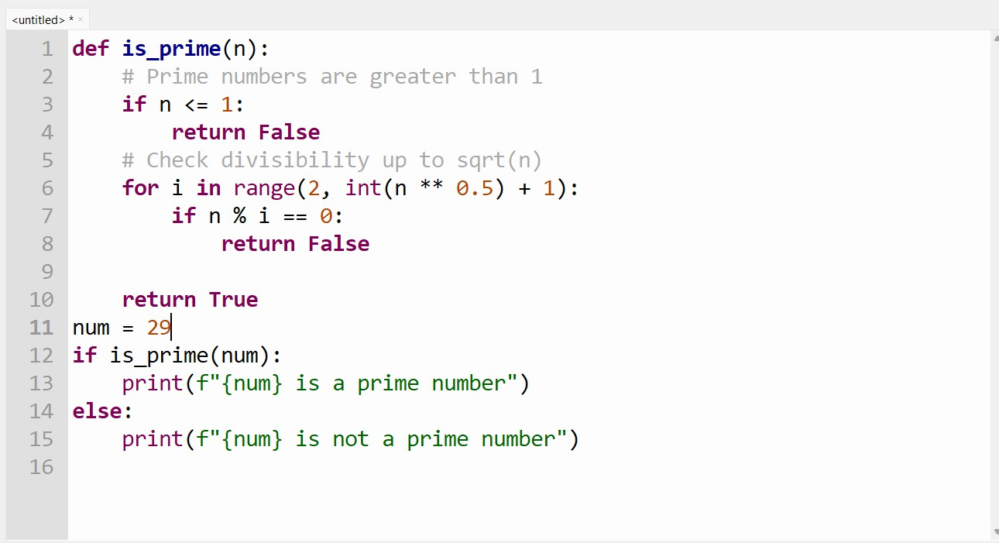
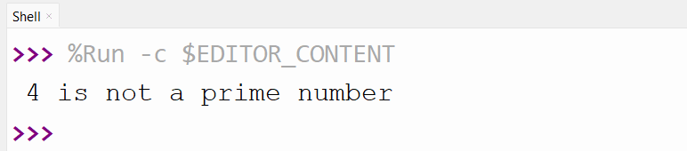
OUTPUT:
Code Explanation:
- The function is_prime(n) checks whether a number is prime.

- If the number is less than or equal to 1, it returns False because prime numbers start from 2.
- A loop runs from 2 up to the square root of the number to check divisibility.
- If the number is divisible by any value in this range, it is not prime.
- If no divisor is found, the function returns True, confirming the number is prime.

Task 2: One-Shot Prompting Prompt Used:
Input: [1, 2, 3, 4]
Output: 10
Write a Python function to calculate the sum of elements in a list. CODE:
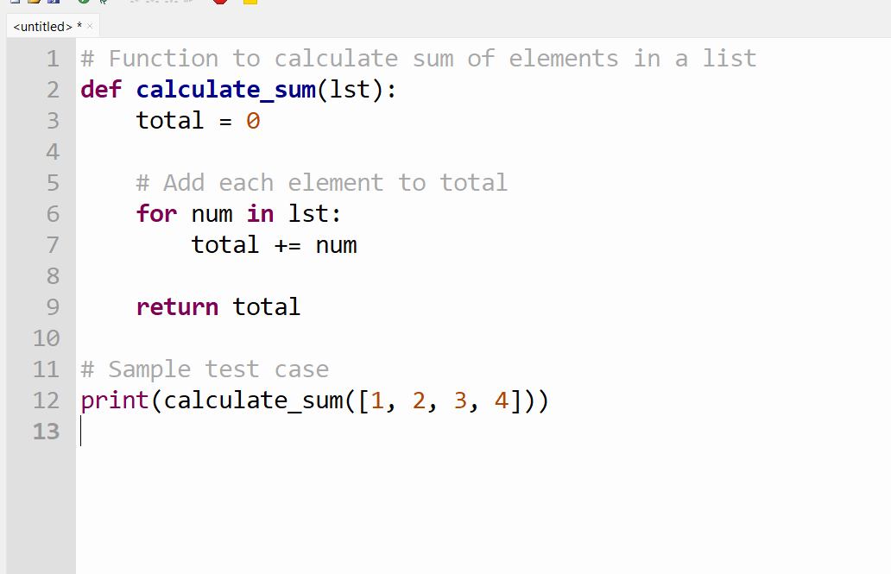

OUTPUT:

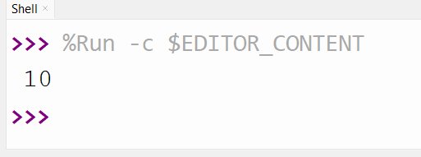

Code Explanation:
- The function initializes a variable to store the sum.
- A loop iterates through the list.
- Each element is added to the total.
- The final sum is returned.

Task 3: Few-Shot Prompting Prompt Used:
Example 1:
Input: "a1b2c3" Output: "123"
Example 2:
Input: "abc456" Output: "456"
Example 3:
Input: "9x8y7" Output: "987"
Write a Python function to extract digits from an alphanumeric string.

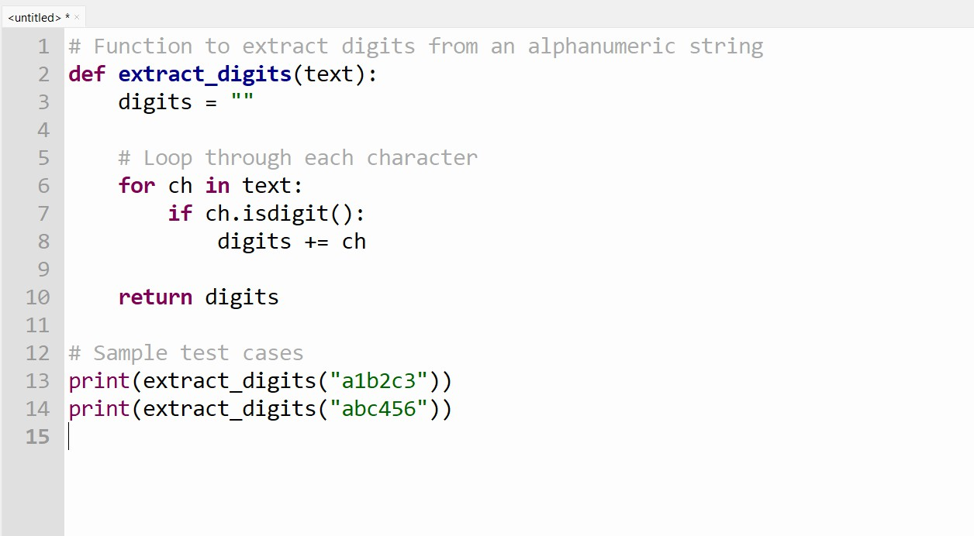
CODE:
OUTPUT:
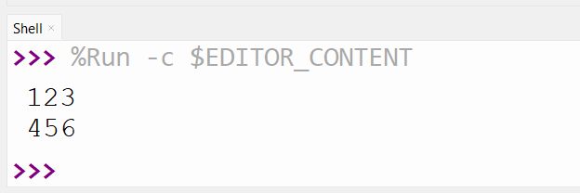

Code Explanation:
- An empty string stores digits.
- Each character is checked using isdigit().
- Digits are appended to the result.
- The function returns only numeric characters.

Task 4: Zero-Shot vs Few-Shot Prompting

Zero-Shot Prompt:
Write a Python function to count the number of vowels in a string.
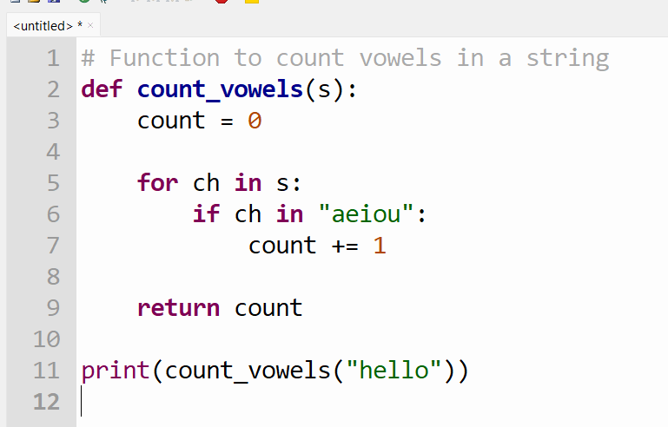
Zero-Shot Code:

OUTPUT:
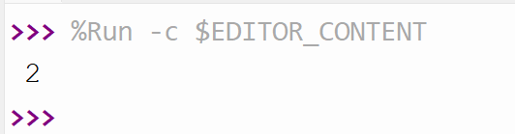

Few-Shot Prompt:
Input: "education" Output: 5
Write a Python function to count vowels in a string.

Few-Shot Code:
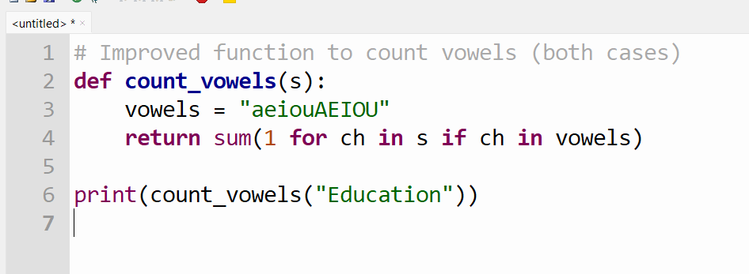

OUTPUT:
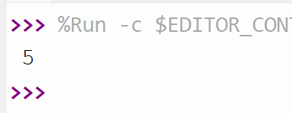

Code Explanation:
- Zero-shot handles only lowercase vowels.
- Few-shot handles both uppercase and lowercase.
- Examples improved correctness and optimisation.

Task 5: Few-Shot Prompting Prompt Used:
Example 1:
Input: 3, 5, 7
Output: 3
Example 2:

Input: 10, 2, 8
Output: 2
Example 3:
Input: 4, 4, 6
Output: 4
Write a Python function to find the minimum of three numbers without using min().

CODE:

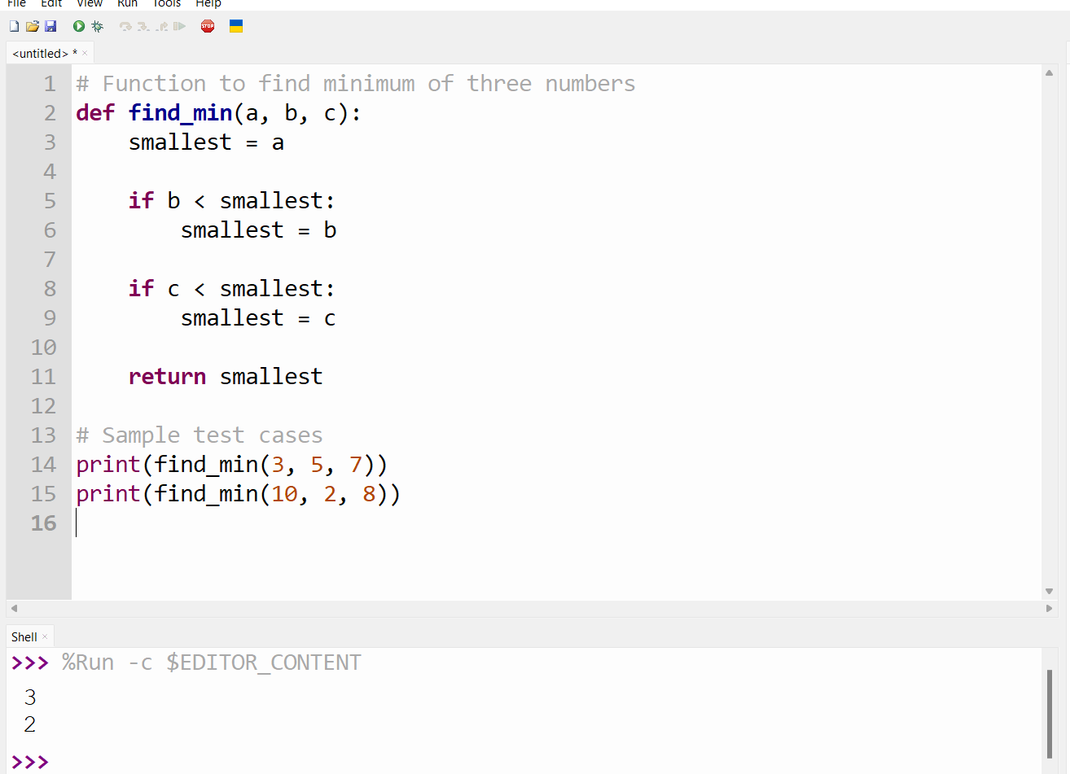

Code Explanation:
- First value is assumed as the minimum.
- It is compared with the second and third values.
- The smallest value is updated accordingly.
- Final minimum value is returned.

